**Assignment 3**

**Deliverables**

* This lab assignment is divided into 4 tasks.
* Use the same document to answer the question and add screenshots.
* After completing all three tasks show this document (with your answers and screenshot added) to your lab professors for grading and demo.
* Due by the start of next Lab class.
* Demo your work to your lab professor during lab class for grades.

(No submission will be accepted, student must demo during lab class).

.

**Note**: All Linux Commands are with small letters!

(Total 15 points, **you lose 1 point for each mistake**)

**\*NOTE:**

* **Names of the directory and file have to be exactly same as specified in the instructions, wrong name will be counted as a mistake.**
* **Read all the instructions carefully.**

**Assignment’s TASKS:**

**Task 1**

**man**

“man” is powerful built in command helps for Linux user, if you need help for Linux command one way is to use man command, e.g. “man cp” or “man touch

( type “q” to quit reading)

Try below command

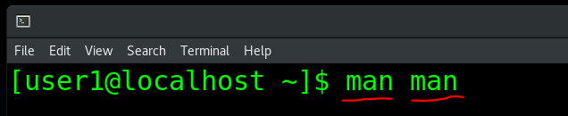

Find DESCRIPTION in man page and answer the following questions

a) What does bold text mean in the SYNOPSIS section of a man page?

Ans: type exactly as shown

b) What does italic text mean in the SYNOPSIS section of a man page?

Ans: replace with appropriate argument

c) What do square brackets [] mean in the SYNOPSIS section of a man page?

Ans: any argument within the [] means that they are optional

d) What does the pipe symbol | (SHIFT-\) mean in the SYNOPSIS section of a man page?

Ans:

e) What do three dots (ellipsis) ... mean in the SYNOPSIS section of a man page?

Ans:

**Task 2 (a)**

1. Go to HOME directory (your personal home directory) and create a directory called “Assignment3” and change your current working directory into Assignment3.
2. Type pwd , it shows this: /home/<student>/Assignment3
3. Create the following tree structure inside Assignment3 directory, Refer image 1 (the blue items are directory; green items are files)
4. For directory “Your_college_Username” use your college username as the name of the directory, eg:- (timg007)

****Note: Small or Capital Letter matter, so do it right.

**\*\*\*NOTE: Your Working directory has to be Assignment3 directory while creating below file structure**.

Image 1

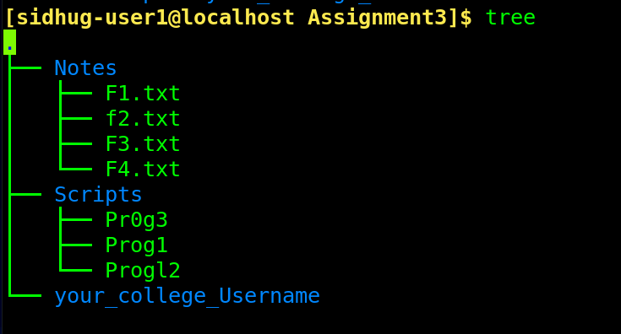

H

Execute tree command under your Assignment3 directory

Add the screenshot of the output

**Task 2 (b)**

1. Create a subdirectory called “Assignment3b” under ~ and change your current working directory into Assignment3b.
2. Type pwd , it shows this: /home/student/Assignment3b
3. Create the following tree structure (refer to image below) inside Assignment3b directory **in one command line**. (the blue items are directory; green items are files).
4. For directory “Your_Student_Number” use your student number, eg:- (04345678)
5. **\*\*Create below file structure in one command line. Hint: use { } and ;**
6. **You are not allowed to change the directory**

****Note: Small or Capital Letter matter so do it right.

**\*\*\*NOTE: Your Working directory has to be Assignment3b directory while creating below file structure**.

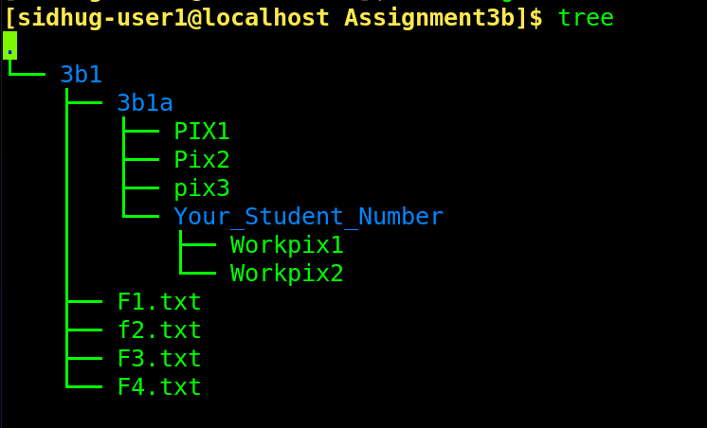

Once you done with above tasks, run tree command

Add screen shot of command line used to create above file structure

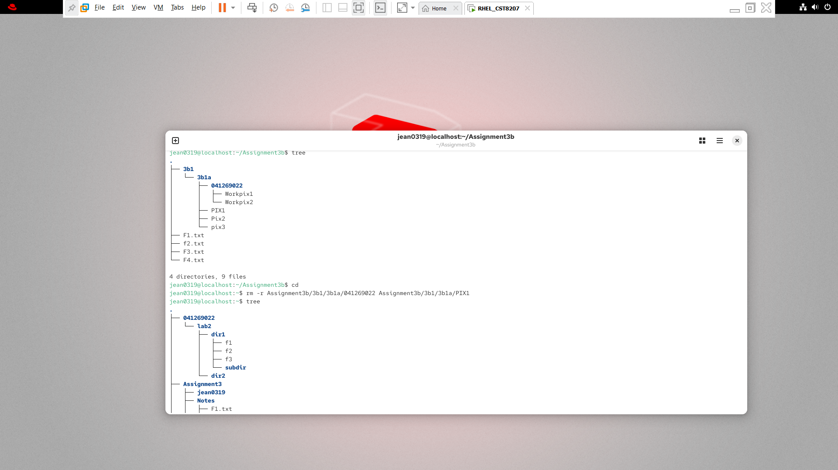

Add Screenshot of the output from command tree

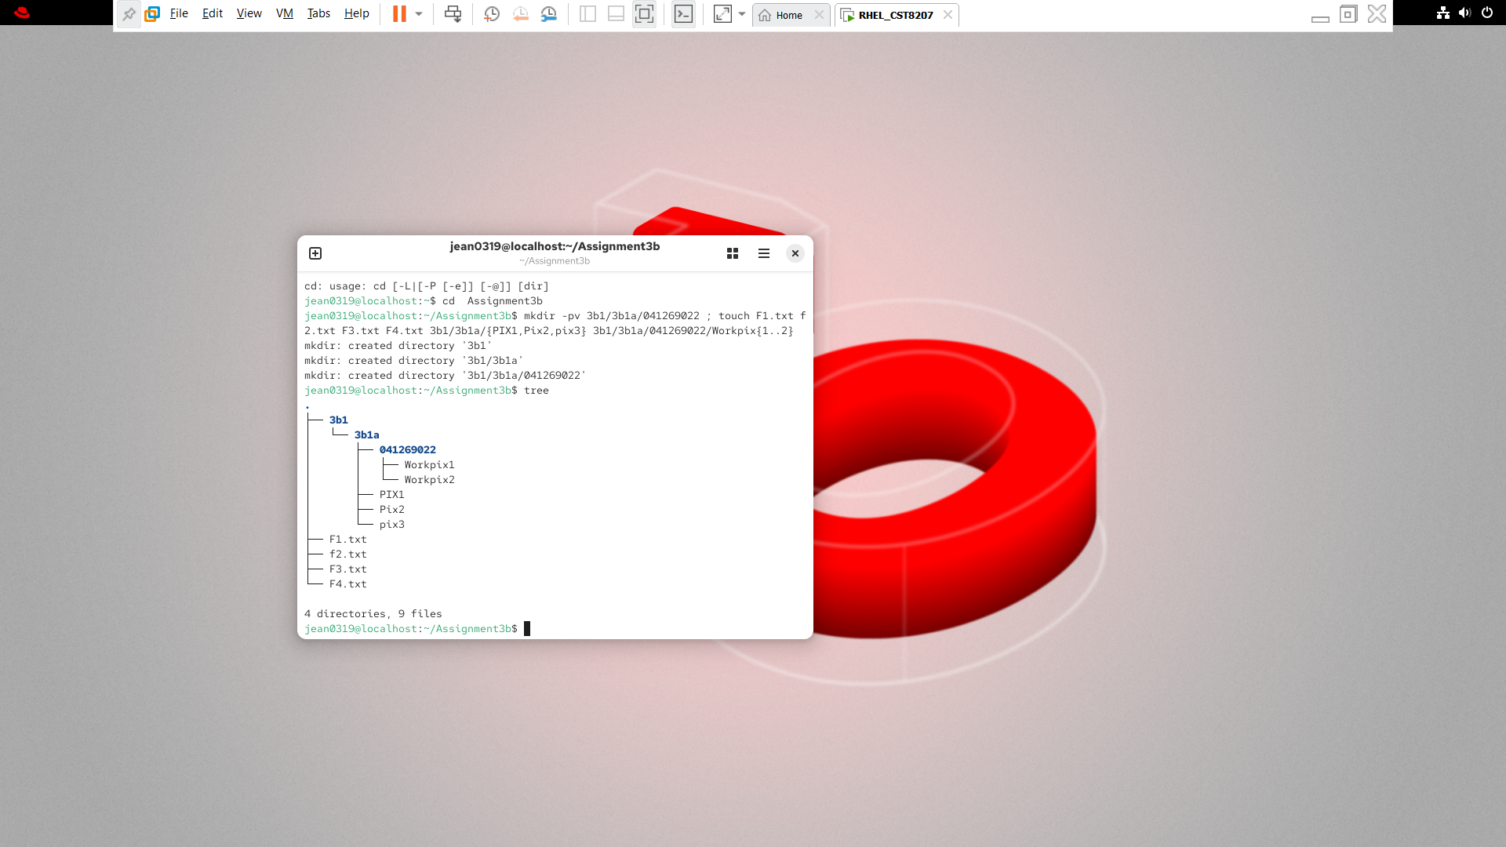

*Task2b Cont….*

* Now Make your personal HOME directory as your working directory
* *Being in your HOME directory*

1. Delete the Your_Student_Number directory (you created in task2b) and PIX1 file using relative path in one command line.

Add screenshot of command line here

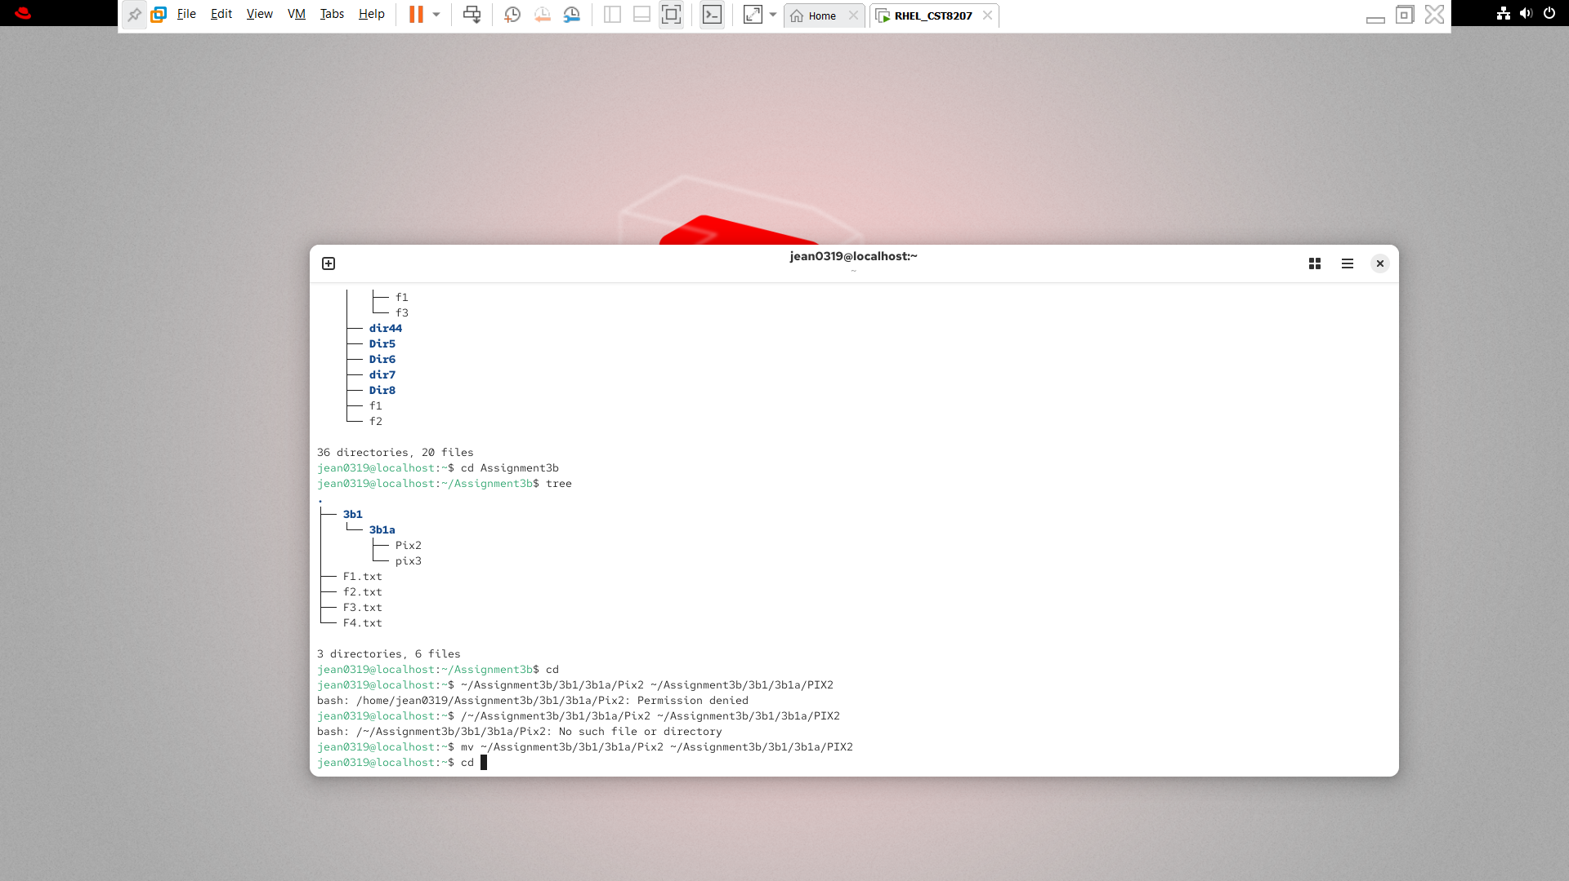

1. rename Pix2 to PIX2, using absolute path.

Screenshot of output and commands line here

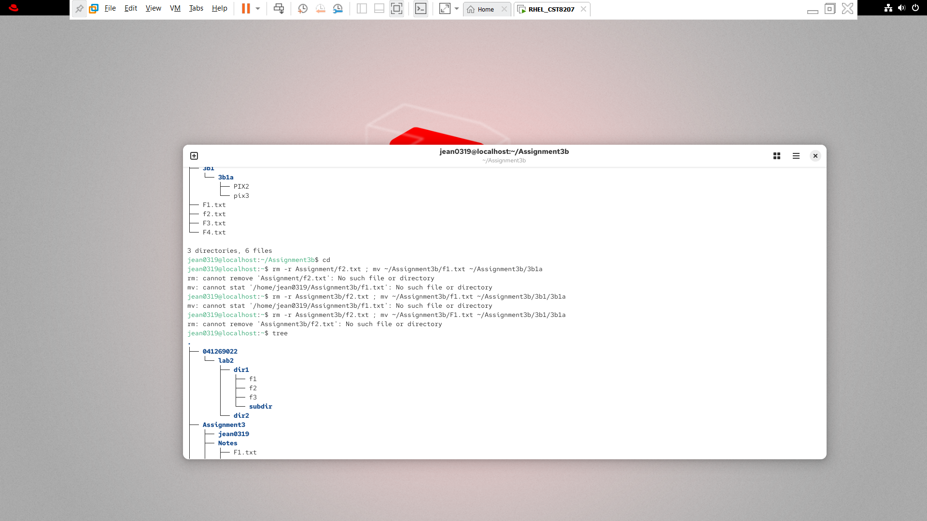

1. Now go to Assignment3b directory and run tree command again

Take screen shot (Screenshot here)



* Now Make your personal HOME directory as your working directory.
* Being in your HOME directory

1. delete the f2.txt using relative path
2. move f1.txt to 3b1a using Absolute path

(Screenshot of output and command line here)

1. Rename pix3 to PIX3 using absolute path
2. Now run history command , (history command shows the record of your previous commands, so the lab professors could verify that you entered the proper command to achieve results)
3. Take screen shot of the history command output

$ **history | tail -30**

(Screenshot here)

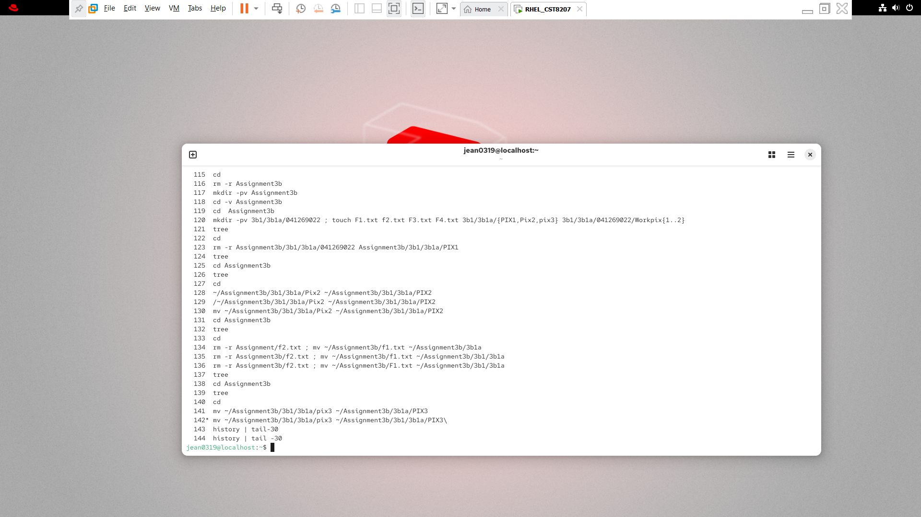

1. Using man page, find out about date command. You are asked to run date command with proper switches to show only today weekday (for Example:- if today is Tuesday then it shows only **Tuesday as output**),

(Screenshot of the output and command line here)

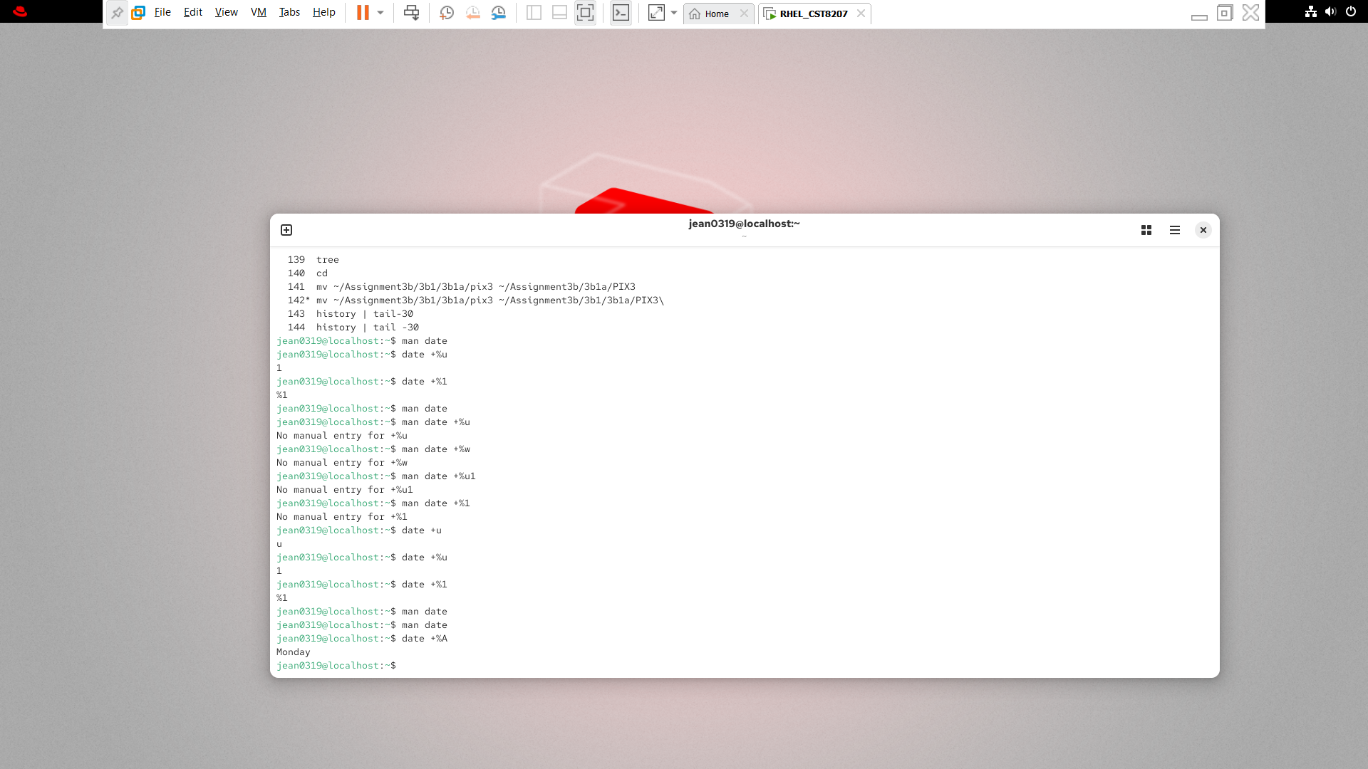

Q-: Rewrite each pathname as a simplified absolute pathname with no . or .. references:

1. /home/me/../you/../../etc/../home/me/../you/../me/../.. = /

2. /usr/./bin/../lib/../../etc/../usr/./lib/../bin/./bar = /usr/bin/bar

3. /../../var/./a/../var/b/../../etc/./bar/../foo /var/etc/foo

4. /.././var/./a/./../var/b/a/../etc/./bar/.. /var/var/b/etc

Q-B: What is a hidden file and how you could list the hidden files in a directory?

Ans: a hidden file is any file that starts with an .

**Task 3**

Reminder from past week, you have created below directory structure [check assignmenr2 if you forgot),

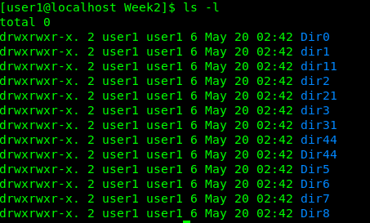

1. And now being in your personal HOME directory creates three files called (L1, L2, L3) under every sub-directory of week2 directory, **in a single command line.**
2. Once you done, run tree command in your HOME directory to show tree file structure of Week2 directory

(Screenshot of the command line)

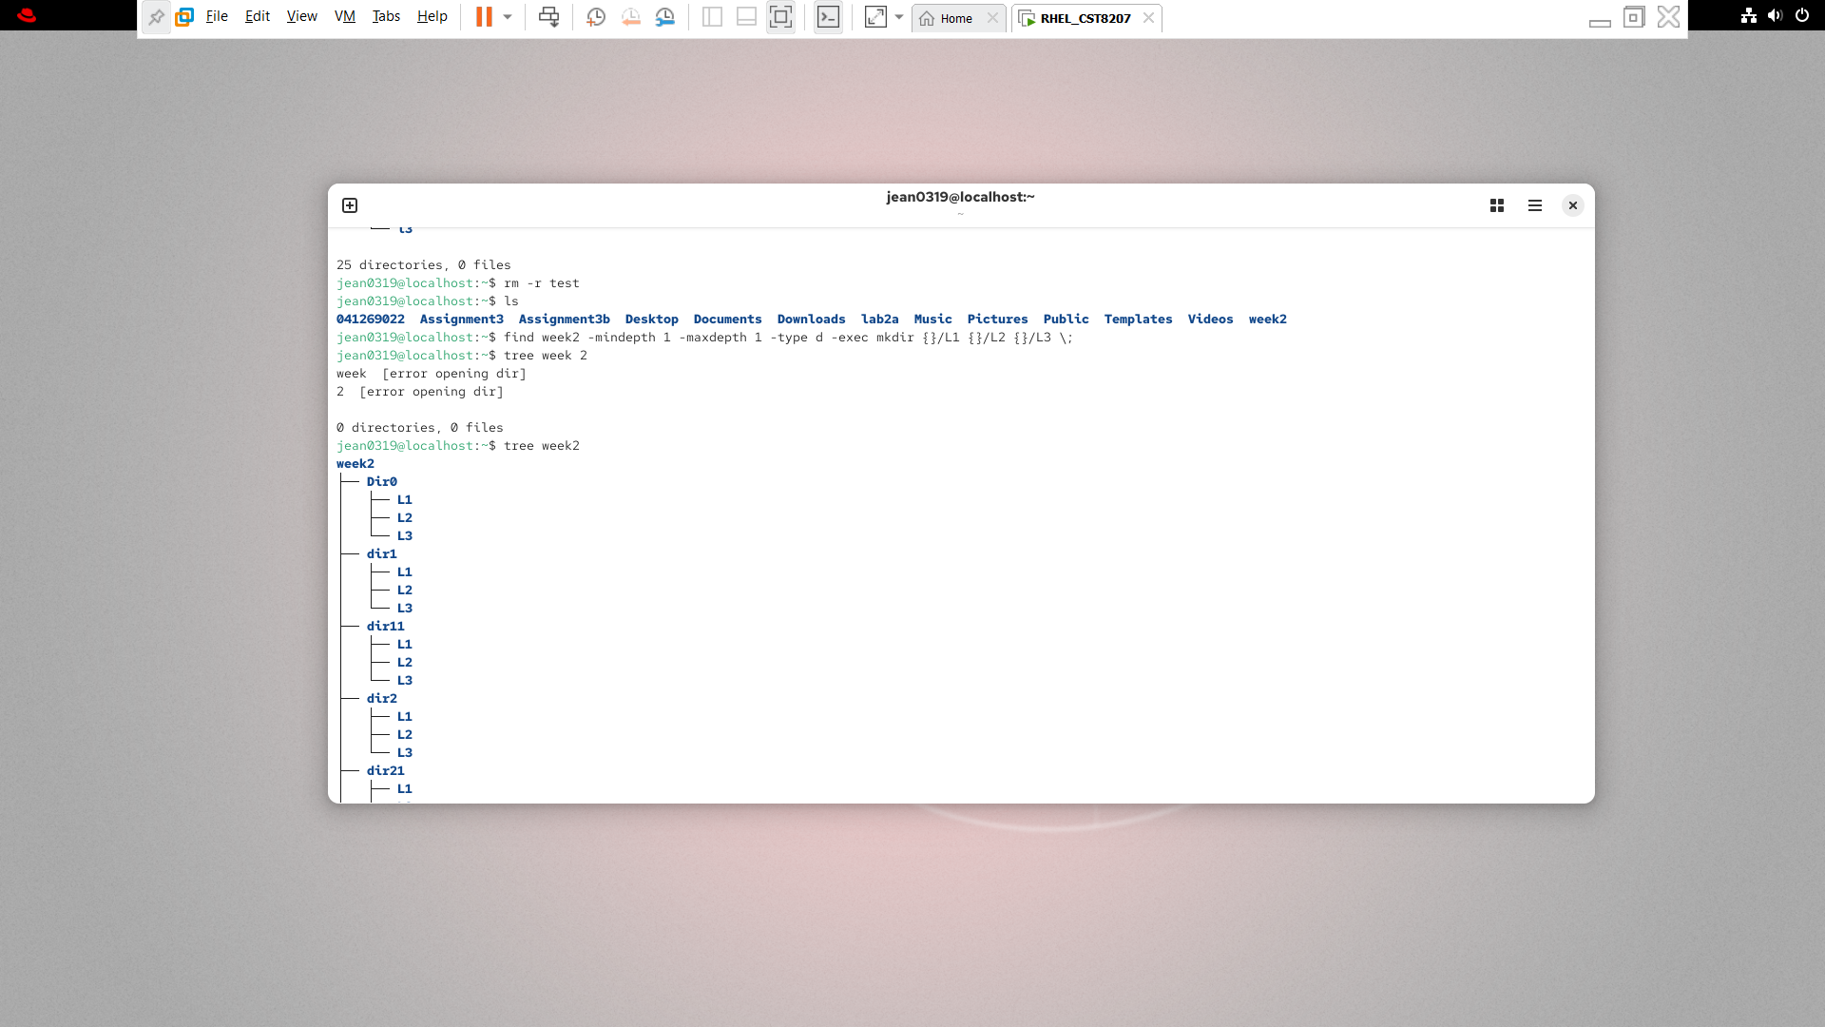

(Screenshot for the tree command output)

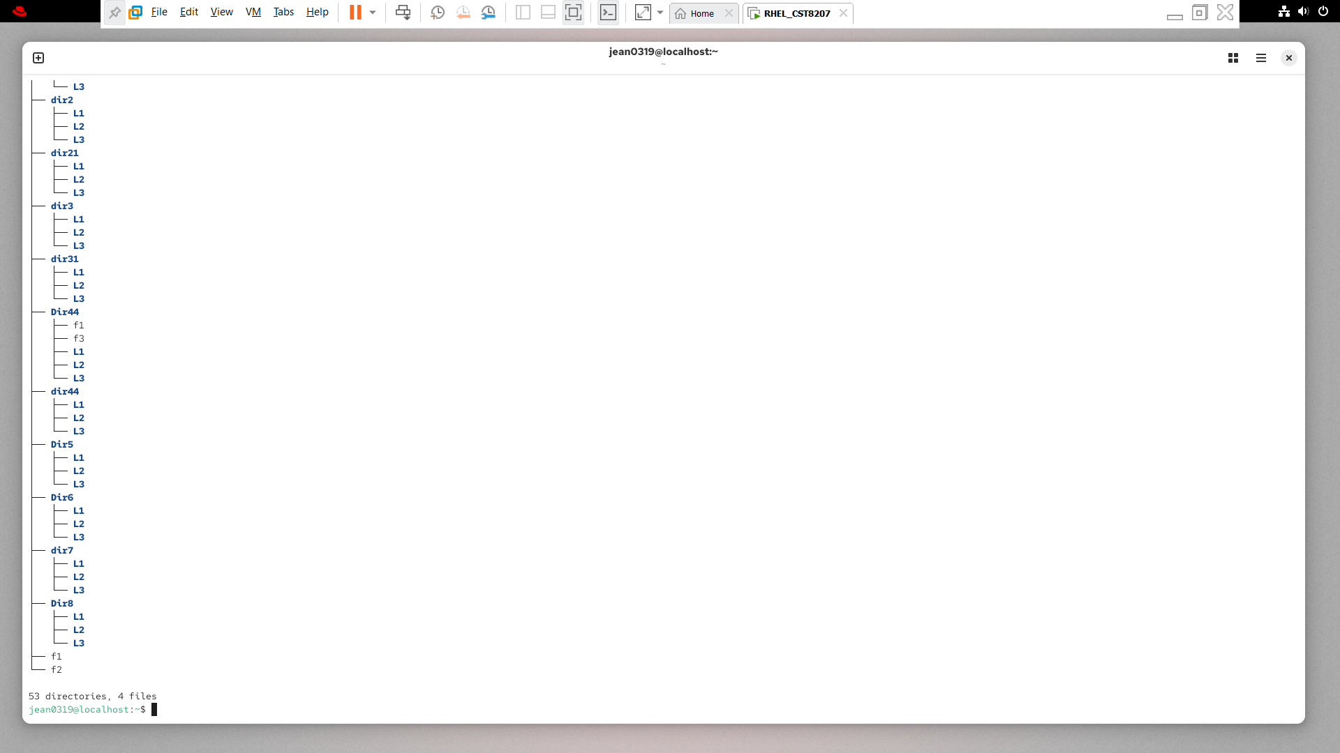

**Task 4**

**Part1**

**Path name expansion (Globbing)**

The useful command is echo to see how patterns expand first, before you use them in a real command line, for example try to expand the pattern using echo command.

**Try this**

$ echo *

$ echo /dev/sd*

$ echo /bin/*sh

**Explain what you observed**

**Anything before the aseterisk was matched in the echo, for the hidden asterisk by itslef it matched all of the directories under the current directory**

**Part2**

Create ~/Assignment3/Task4 directory.

Under Task4 create the below file structure (Blue – directorys)

(White – files)

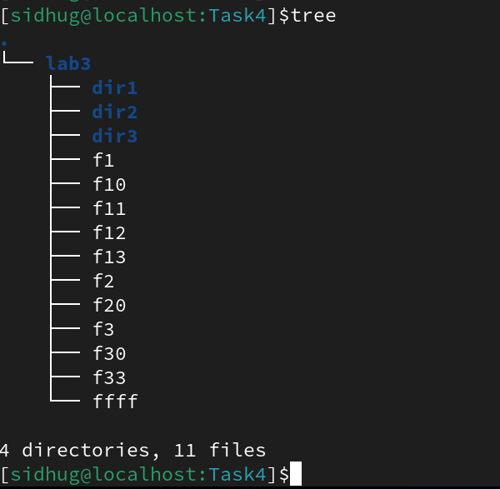

Screen shot here

**Use the echo command to see how patterns expand first, before you use them in a real command line.**

$ **cp f? dir1**

1. Which files have been copied to the directory **dir1**? (First try to **answer without typing** the command.)

Ans- Only the files that have just the one digit not the files that have multiple digits in them

$ **cp f?0 dir2**

1. Which files have been copied to the directory **dir2**? (First try to **answer without typing** the command.)

Ans- all of the files that end wih azer digti will be copied

$ **cp f?3 dir3**

1. Which files have been copied to the directory **dir3**? (First try to **answer without typing** the command.)

Ans- all of the files that have a 3 in the singles digit place

$ **cp ?? ????? dir3**

1. **Why** does the above command line give an **error** message from the copy command?

Ans-because you dont have an argument before or after the GLOB charcter

$ **ls /dev/tty\***

1. The above command shows all terminal devices configured in your Linux system. Using this method type a command to show **only** terminal device names with 4 characters

i.e. shows **tty1** and **tty6** and **tty9**, etc. but does *not* show **tty** or **tty12** or **tty60** etc.?

Ans-

Screenshot of command line with output

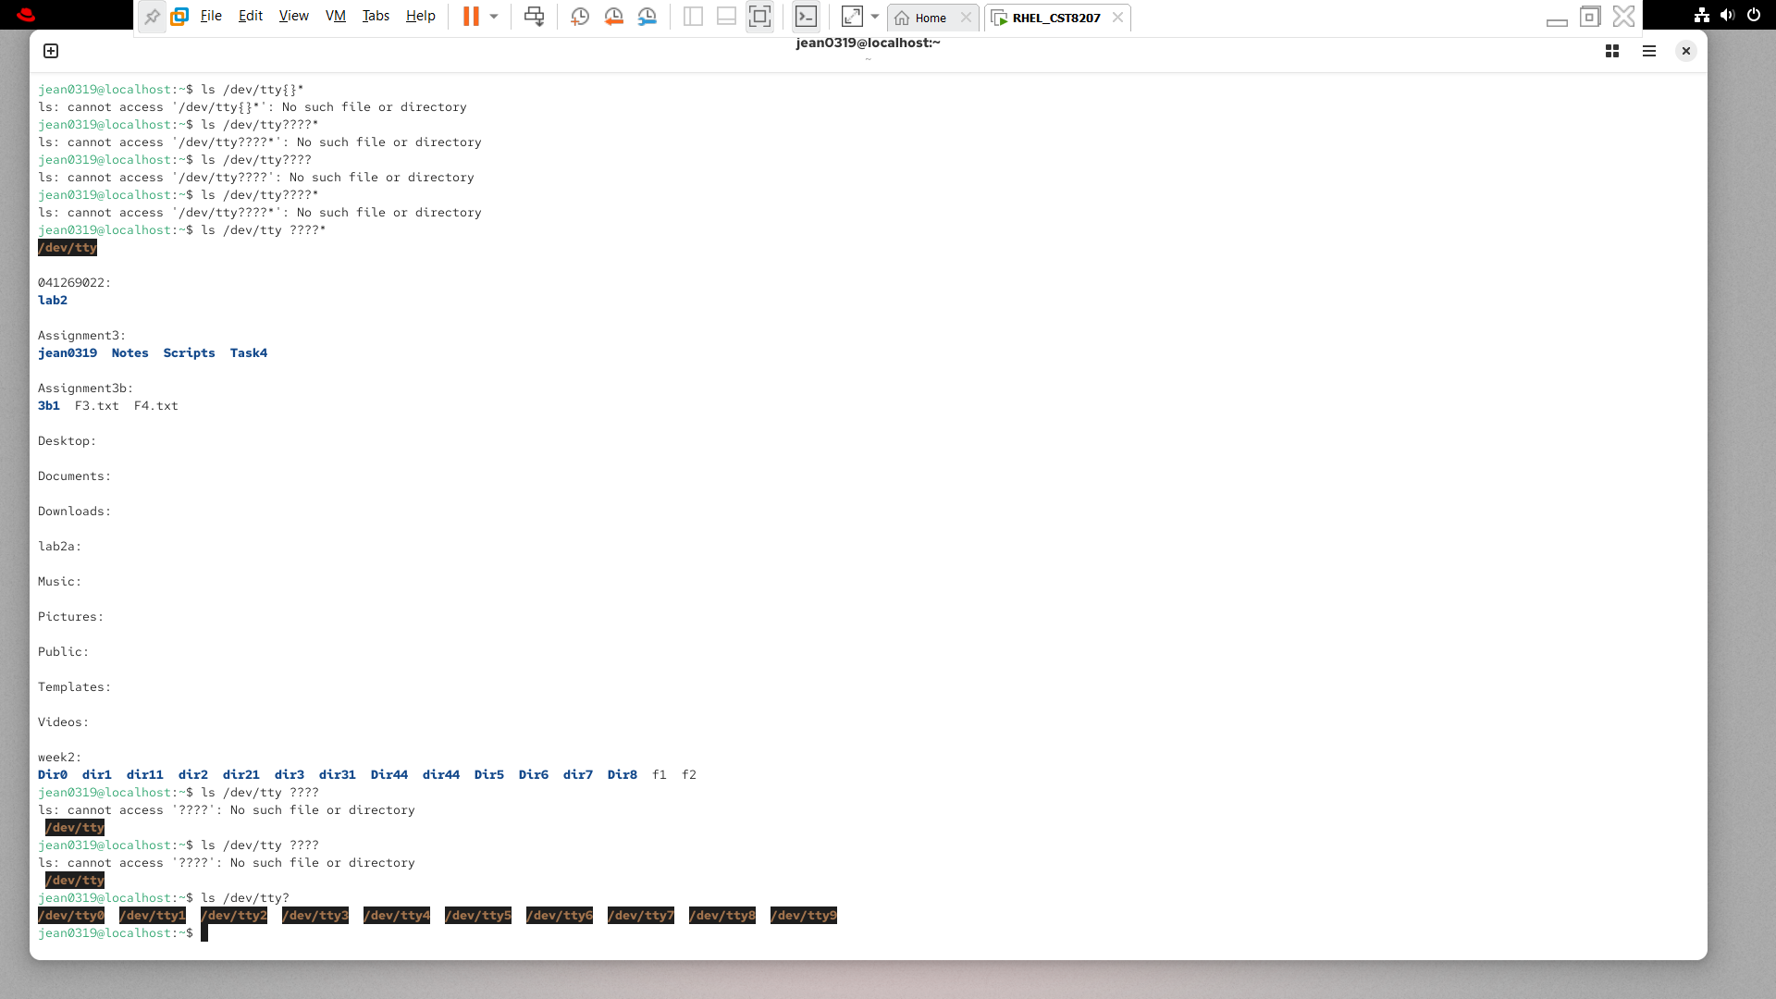

**Part3**

Using * to match zero or more characters

execute below commands.

$ **mkdir ~/Assignment3/Task4/lab3.2 ; and make directory lab3.2 as your current working directory**

1. Copy all the contents of **lab3** into **lab3.2** being in lab3.2 directory. (just the content not the lab3 directory itself)

Screen shot of command line

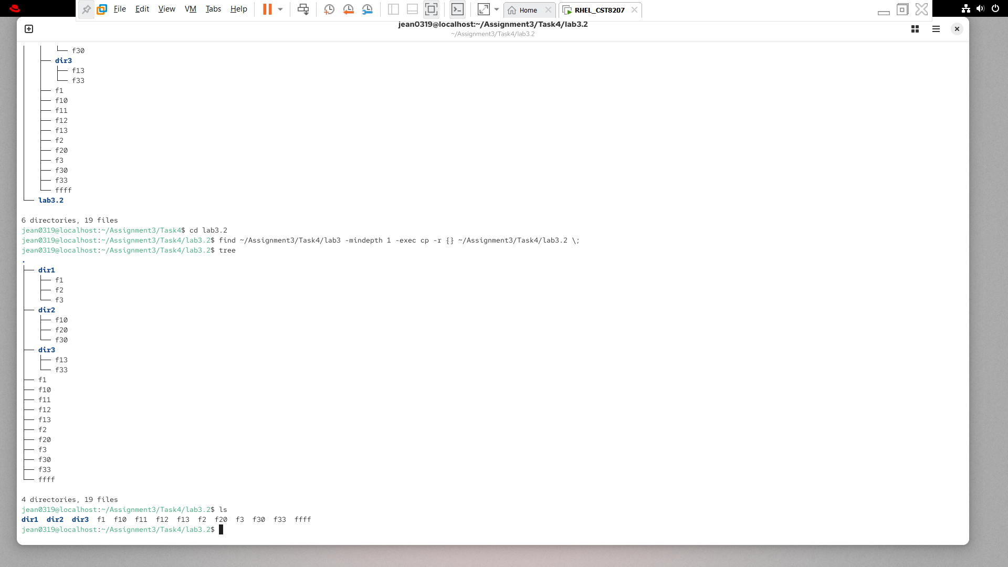



(take screen shot of output of ls command and paste here)



1. What is the output of the below command (First try to **answer without typing** the command.)

$ **ls f\*** all of the file with f will be returned

$ **ls -d d\*** all of the directories with d will be returned because of the directory option (-d)

Explain why the output of above commands are the way they are?

Ans:-

1. Explain what would be the output of the below commands without using the shell terminal?

$ ls dir?/* all of the files hat exist in directories with only one digit will be listed

**Part4**

Using [ ] to match a single character from a list of characters

Square brackets are shell meta-characters that indicate a GLOB pattern match for any one character in the list of characters between the square brackets. You can also match any one character that is not in the list by starting the list with an exclamation point !, e.g. **[!abc] or [^abc]**

Go to ~/Assignment3/Task4 directory and create below file structure (Blue – directory)

(white – file)

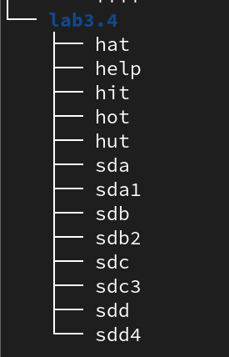

What is the output of below commands? (First try to **answer without typing** the command.)

$ **ls h[ao]t** all the directories with an h and the middle letter of either an a or o are listed

$ **ls h[aeiou]t** all of the directories that start with an h and end with a t and have middle characters that are vowels are listed

$ **ls h[aeiou]\*** all of the directories that start with an h and have a vowel are listed

$ **ls sda[1-4]** all of the dirctories that start with sda and end with numbers 1-4 are listed

$ **echo sd[!ab][!12]** all of the direectories that start with sd and dont have ab or 12 are listed

**After completing your assignment show your document to your lab professor**